VLAN Trunks:

This enables devices connected to different switches but in the same VLAN to communicate without going through a router

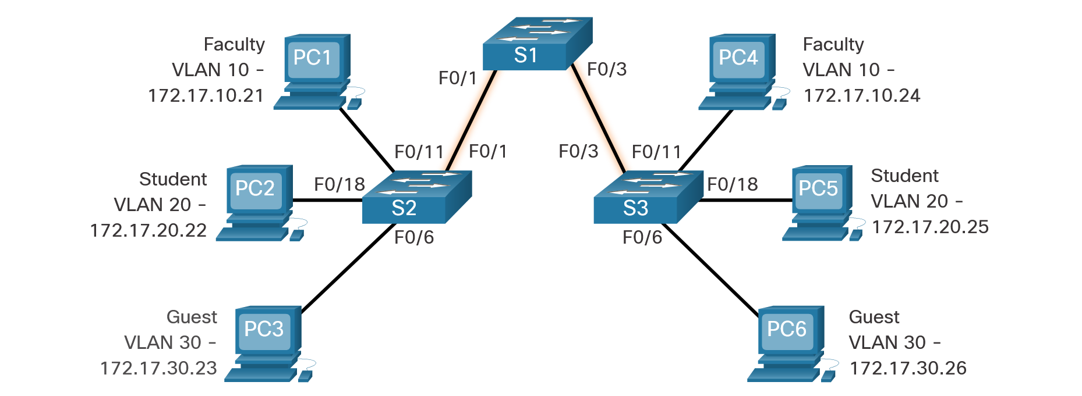

VLAN keret: (802.1Q)

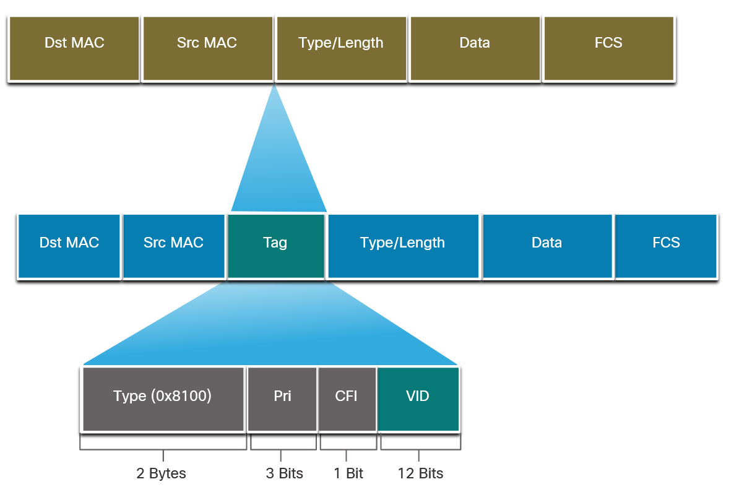

VLAN létrehozás:



VLAN rendelés porthoz:

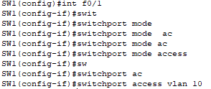

VLAN port trunk mode:

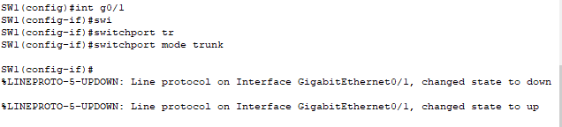

Voice VLAN:

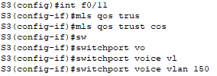

DTP – Negotiated Interface Modes

